Git-HOL Exercise 3 Report
Student: Rishi Gupta
Week: WEEK - 7
Exercise: 3. Git-HOL (Git Branching and Merging)

Objective
The objective of this exercise was to practice creating a new Git branch, making changes on that branch, comparing it with the main branch, merging the changes into the main branch, and understanding the basic Git branching workflow.

Procedure
- Created a new branch named GitNewBranch.
- Verified the available branches using git branch -a.
- Created a new file named branch-demo.txt inside the WEEK - 7/3. Git-HOL folder.
- Added and committed the file in the GitNewBranch branch.
- Checked the repository status.
- Switched back to the main branch.
- Compared the main branch and GitNewBranch using git diff.
- Merged GitNewBranch into the main branch.
- Viewed the commit history using git log --oneline --graph --decorate.

Execution Screenshots
Creating the GitNewBranch branch.
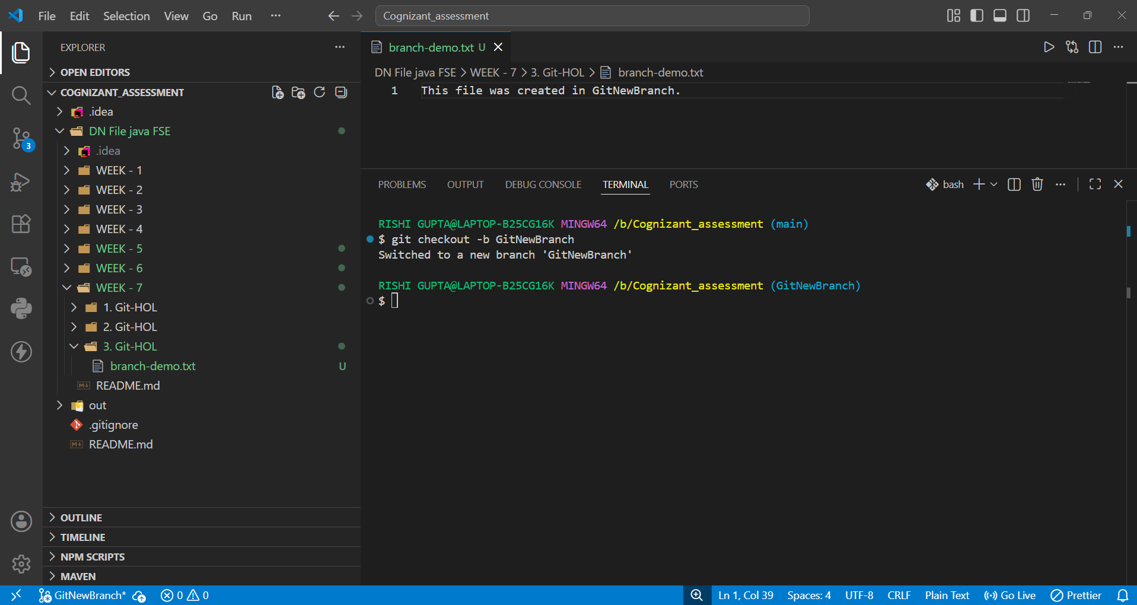
Listing all branches using git branch -a.
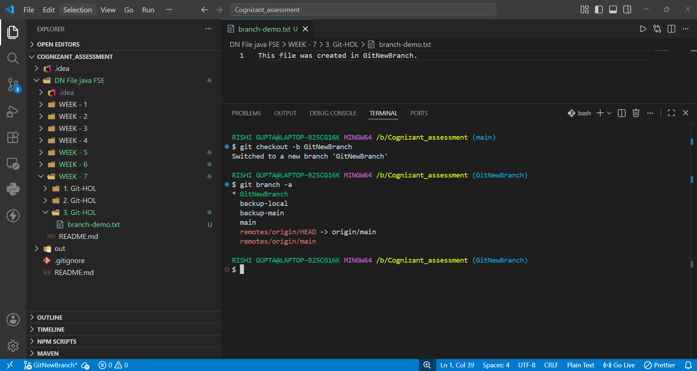
Creating and editing branch-demo.txt.
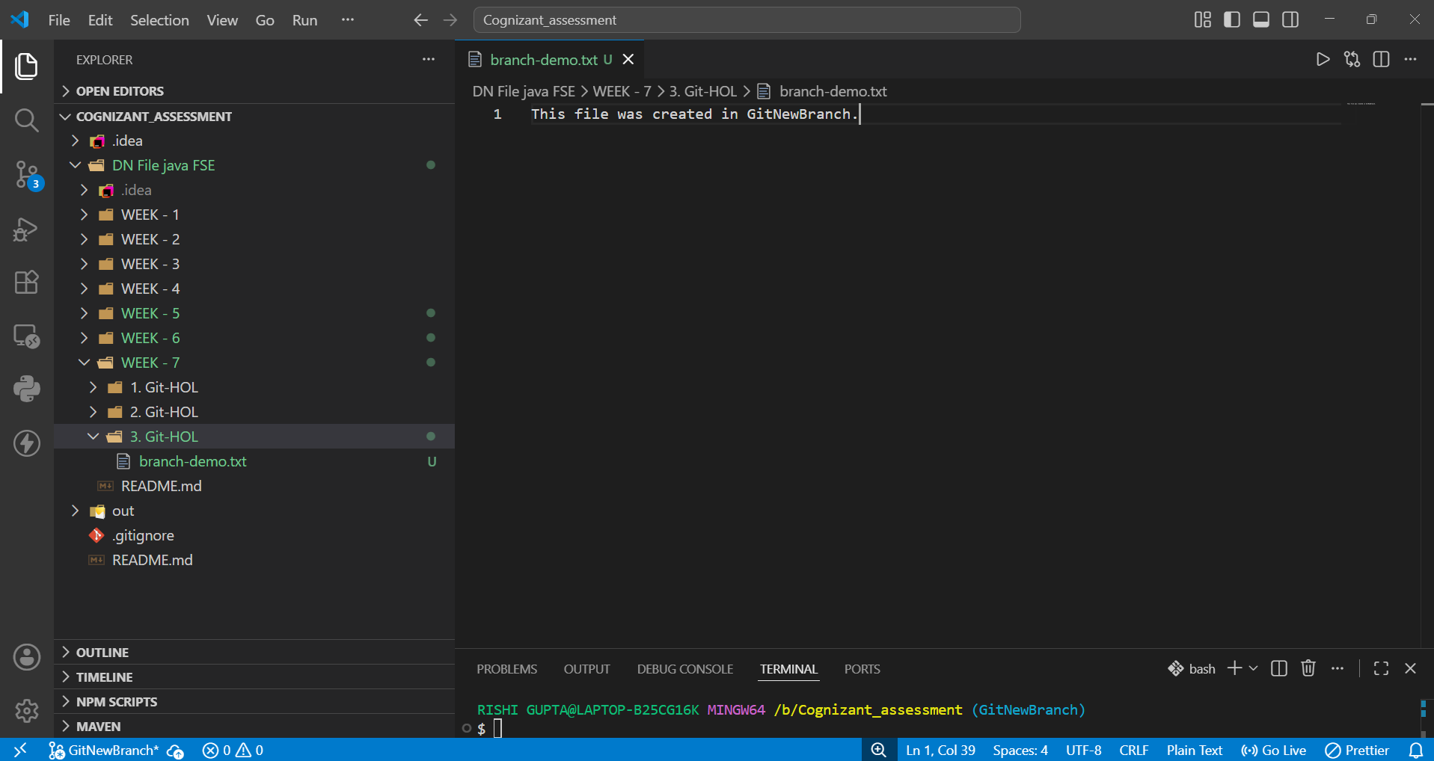
Committing the new file and switching back to main.
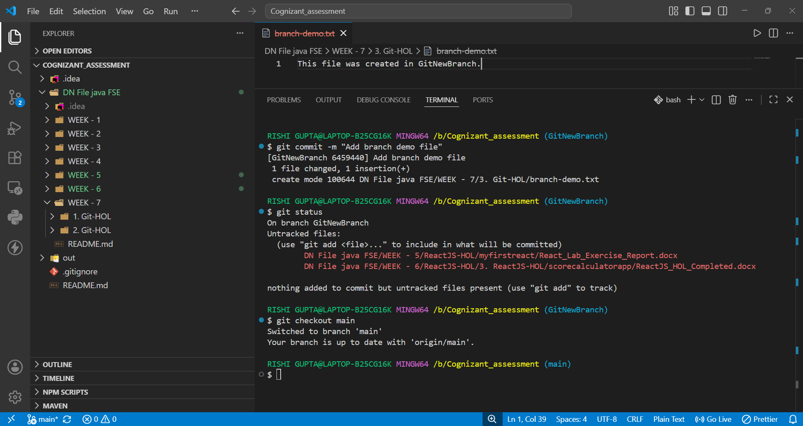
Comparing the main branch with GitNewBranch and merging.
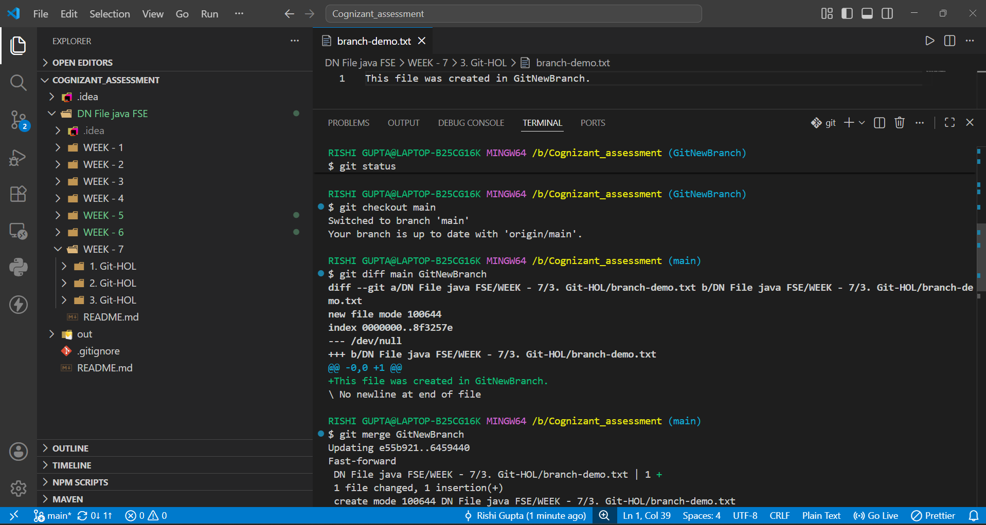
Viewing the commit graph.
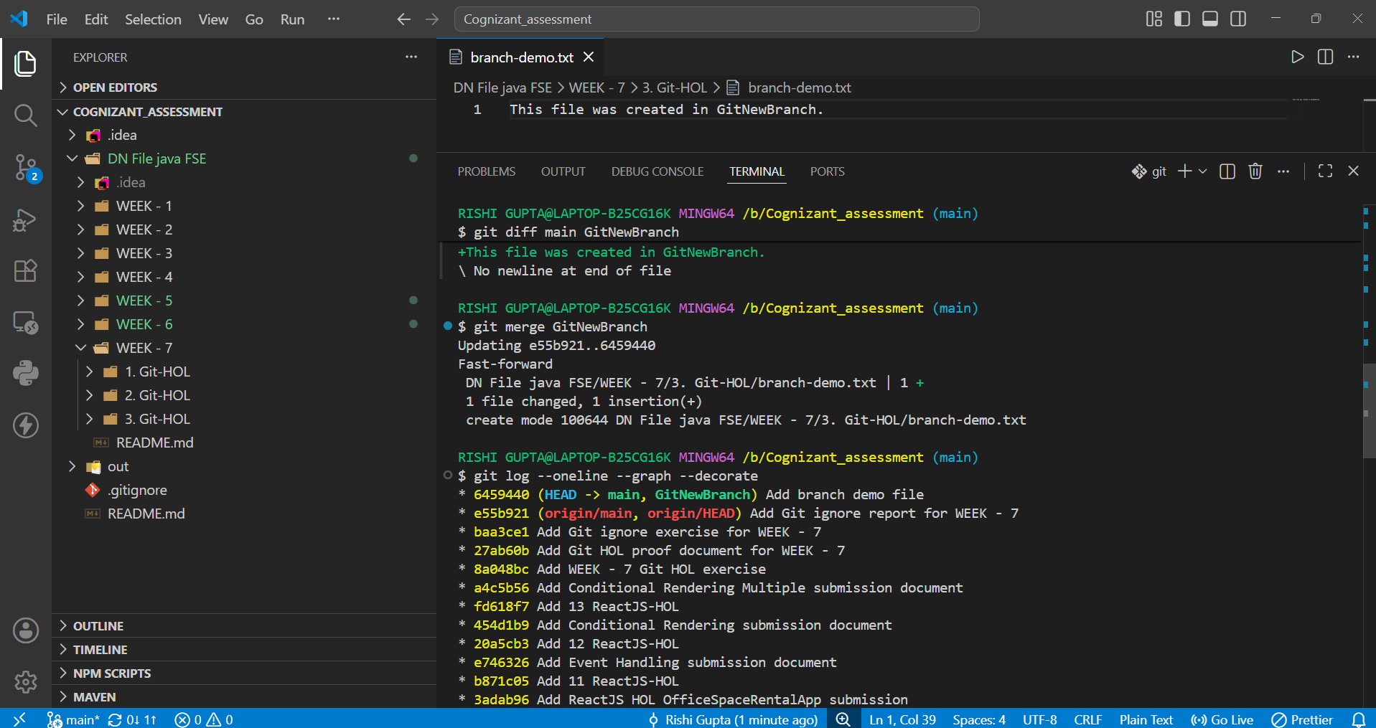
Project Explorer showing branch-demo.txt in the exercise folder.
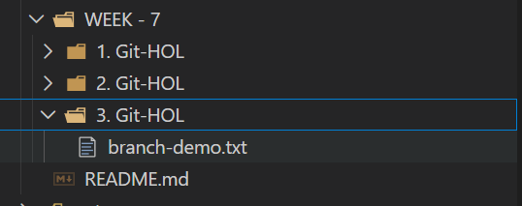

Observation
The exercise demonstrated how Git branches allow independent development without affecting the main branch. After verification, the changes were successfully merged into the main branch.

Conclusion
This exercise improved my understanding of Git branching, comparison, merging, and commit history visualization using Git commands.

